**Assignment 5**

**Points 20**

**Please follow the following instructions to complete this assignment.**

1. Open Xcode from the launchpad of your mac.
2. Click on create a new Xcode project. Select the iOS template and click on the App application.
3. Click on next which will prompt you to choose options for the project.
4. Provide product name as **Lastname_WordGuess**, “**nwmsu**” for organization identifier, “**storyboard**” as interface and swift as language.
5. Click on next and select an appropriate location to save your app and click on create. A project directory will be loaded.
6. When you are done with selecting the location of the project on your local storage, moving further you can see project settings screen. Set your **Project Format** to “Xcode 13.0-compatible” in your Project Document settings.
7. Now look into **Deployment Info** settings on the same project settings and set it to “ios 15.5” and make sure to check iPhone and iPad. Check below image and highlighted portion with red and follow accordingly.

1. **Note:** Follow the exact instructions given and don’t modify any other settings as it causes application not to run in different machines. Use constraints wherever necessary.
2. From the project navigator click on “Main.storyboard” file, a blank mobile screen will be loaded where the required fields for an app need to be added.
3. Add 3 labels **Total number of words guessed successfully**, **Total number of words remaining in game, Total number of words in game** and add constraints accordingly.
4. Create IBOutlet for all the labels and give them the names as **wordsGuessedLabel,** **wordsRemainingLabel, totalWordsLabel.**
5. Add another label for the title of the app and name it as Word Guess. Use your own styling, Add constraints to this labels Top, left, right – 8,16,16 and also add a height constraint of your own.
6. Add in another label and fill it with “_ _ _ _” , text in the label should be centered. Constraints are as follows: Top, left, right – 8,16,16 and give it a height : 20. Make a IBOutlet Connection and give it a name as **userGuessLabel.**
7. Now add a Text Field with the constraints Height: 34, Width: 30. In the attribute Inspector select the Spell Checking to NO, Correction: NO, Capitalization to: All Characters. Make a IBOutlet connection for this textField and give it a name **guessLetterField.**
8. Now add a button beside to the above Text Field and give the text as Guess a Letter**.** Constraints are Width: 150, Height: 30. Add the above button and Text Field to a stack and add a Top : 8 constraint for this stack. While making a IBAction connection, give it a name **guessLetterButtonPressed.**
9. Now add a Label below the stack which is a Hint label, and give the constraints as top,left,rigtht,height : 8,16,16,40. Name it as **hintLabel** while making a IBOutlet connection.
10. Now add in another label below the above label for the game status. Give the constraints as Top,left,right,height : 8,16,16,80. Make sure text will show on multiple lines and not be cut off with “...”. Make the default text as “You have  
    Made Zero Guessess” and make sure the text is centered. Name it as **guessCountLabel** while making an IBOutlet connection.
11. Now add in another label below the above label for the game status. Give the constraints as Top,left,right,height : 8,16,16,80. Make sure text will show on multiple lines and not be cut off with “…”. Make the default text as “This is a status label of App” and make sure the text is centered. Name it as **statusLabel** while making an IBOutlet connection.
12. Now add a play again button and give the constraints as Top,width,height: 8,90,30. Make the button hidden by default. Name it as **playAgainButtonPressed** while making and IBAction connection
13. Add an image view at last and name it as **displayImage** while making connection. When a word is guessed correctly respective image should be displayed.
14. Now we are done with the UI part. Make sure all the connections for the controls are made correctly.

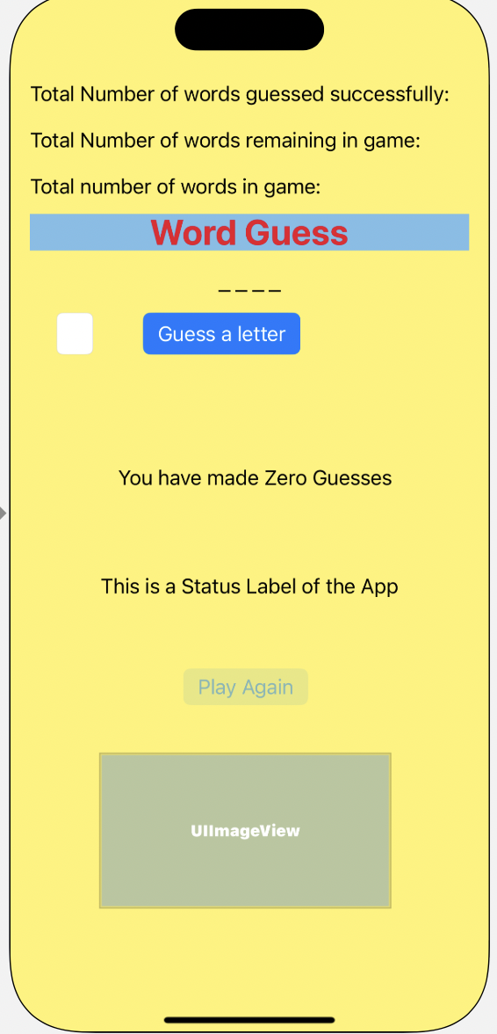

1. Now **declare an array with at least 5 words and the related hints of your own**. Choose 5 images for above words and display in image view when word is guessed correctly. Whenever we build the app, userGuessLabel in the UI should update with number of “_” same as the letters in the word of the array.
2. Initially totalWordsLabel should contains number of words in the array. Words Guessed : 0, Words Remaining : 5, Words in game : 5
3. Whenever the guessed word is correct these labels should be updated accordingly.
4. guessLetterField Label should take only the last character even though you enter any number of characters. Type in a letter in this Text Field using the keyboard of the simulator.

If the keyboard is not showing up, then select I/O option for the simulator, then you can find Keyboard and then toggle the keyboard.

1. Guess a letter button should enabled only if there is any text in the Text Field else disable it (**use editing changed event**)
2. Declare a constant maxNumOfWrongGuesses as 10. You are allowed to make only 10 wrong guesses for each word.
3. When the application is launched, it should display as shown in **Figure 01.**
4. guessCountLabel displays the count of the guesses you have used. You can refer **Figure 02** from the below picture.
5. Whenever you have guessed the word correct, related image for the word should be displayed and play again button should be enabled. On clicking, it should go to the next word. **Refer to Figure 03.**
6. If you used all the available guesses for a word, guessCountLabel should display “You have used all the available guesses, Please play again” please refer to the image below for exact message and play again button should be enabled. Once you click on play again button you will get another chance to guess the same word. (Note: It should not start from the beginning of the words). **Refer to Figure 04 and Figure 05.**
7. **Refer to Figure 06** which is the last word in the array. You can observe the wordsRemainingLabel at the top.
8. When ever all the words in the array are completed, statusLabel should display “Congratulations, You are done, Please start over again” and the app should start over again resetting all the labels and play again button should be enabled. On clicking play again button, the app should start again from the beginning. **Refer to Figure 07.**
9. Refer below images for output and have a look of words guessed, words remaining labels how they are updating accordingly for every correct guess.

**Figure 01**

**Figure 02 Figure 03**

**Figure 04 Figure 05**

**Figure 06 Figure 07**

**Please submit your app as compressed file, your compressed files should contain Lastname_WordGuess folder and Lastname_WordGuess.xcodeproj file. Please check your submission by downloading the submitted file and rechecking in xcode.**